Figma Layout for Main or Home Page – v1.2

- Add the Name as
  - ALAR Labs
(Learning and Innovation Arm of ALAR Edge Pvt. Ltd.)

  - Logo Attached.

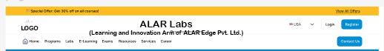

- I have rephrased the Module Titles to be more professional and clearer and added the Tagline. Pls. update the Module title accordingly and add Tag line in each section.

- Propagate these changes to all pages.

- Update menu name accordingly.

Current Section / Context | Module Section Title | Suggested Tagline
Test your Cloud Skills | Technology Readiness Assessment | Benchmark Your Brilliance
Upcoming Instructor-Led Programs | Expert-Led Technology Training | Learn From The Masters
Hands-On Labs | Skill Builder Labs | Practice Makes Perfect
E-Learning (On-Demand Video) | Digital Skills Programs | Master The Tools
Exam Series Programs | Certification Readiness Program | Invest In Your Future
Exam Vouchers Available | Certification Voucher Hub | Unlock Your Potential
Instructor Resources | Trainer Enablement Hub | Empower Educators
Cloud Account Services | Cloud Access Services | Scale Without Limits
Career Assistance | Tech Career Pathways | Bridge to Hire
Exam Vouchers Available | Certification Voucher Hub | Wear Your Achievement

